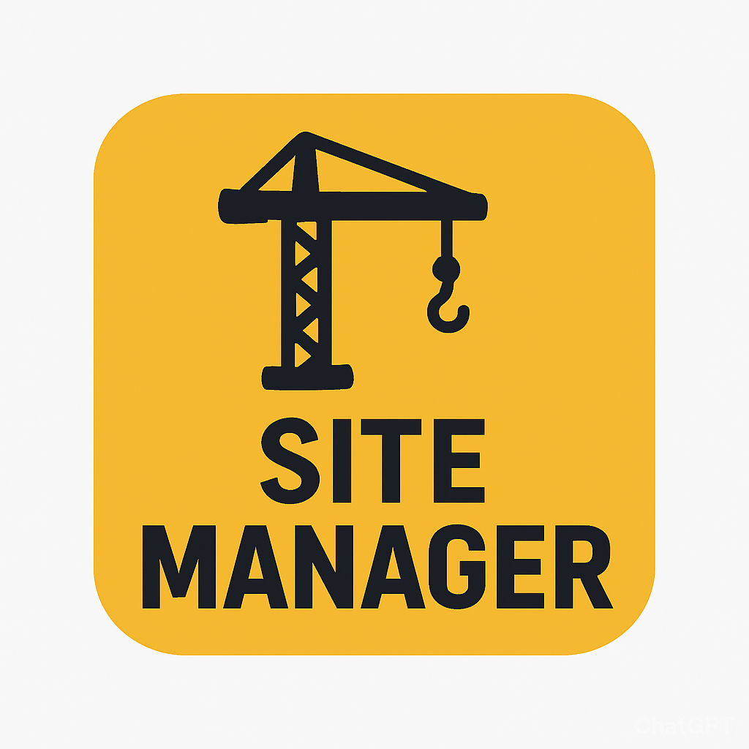

SiteManager

Enrique Garcia,

Kelvin Gordon, Joseph Koop

**Table of Contents** 1

Problem Domain 2

Initial POVs 3

Revised Point of Views 5

HMW Statements 6

Three Best HMW Statements 6

Experience Prototypes 7

Most Successful Prototype 10

Conclusion 10

**Acknowledgement of Generative AI Tools Used** **12**

**Acknowledgement of Assessment Submission** **12**

## Problem Domain

The construction industry faces a common issue when it comes to effectively managing resources, employees,equipment, and project progress. The conventional teaching methods can cause delays, inefficiencies, and misunderstandings. These issues make it difficult for project and site managers to monitor equipment utilization, labor productivity, resource allocation, and project advancements in real time.

Without a centralized system businesses face the risk of cost overruns, scheduling conflicts, and reduced efficiency, all of which can have a negative influence on customer satisfaction and project outcomes.

Goal

The goal of this project is to:

* Track employees, equipment, and projects in real time.
* Streamline resource allocation and reduce inefficiencies
* Automation, to reduce manual entries and errors

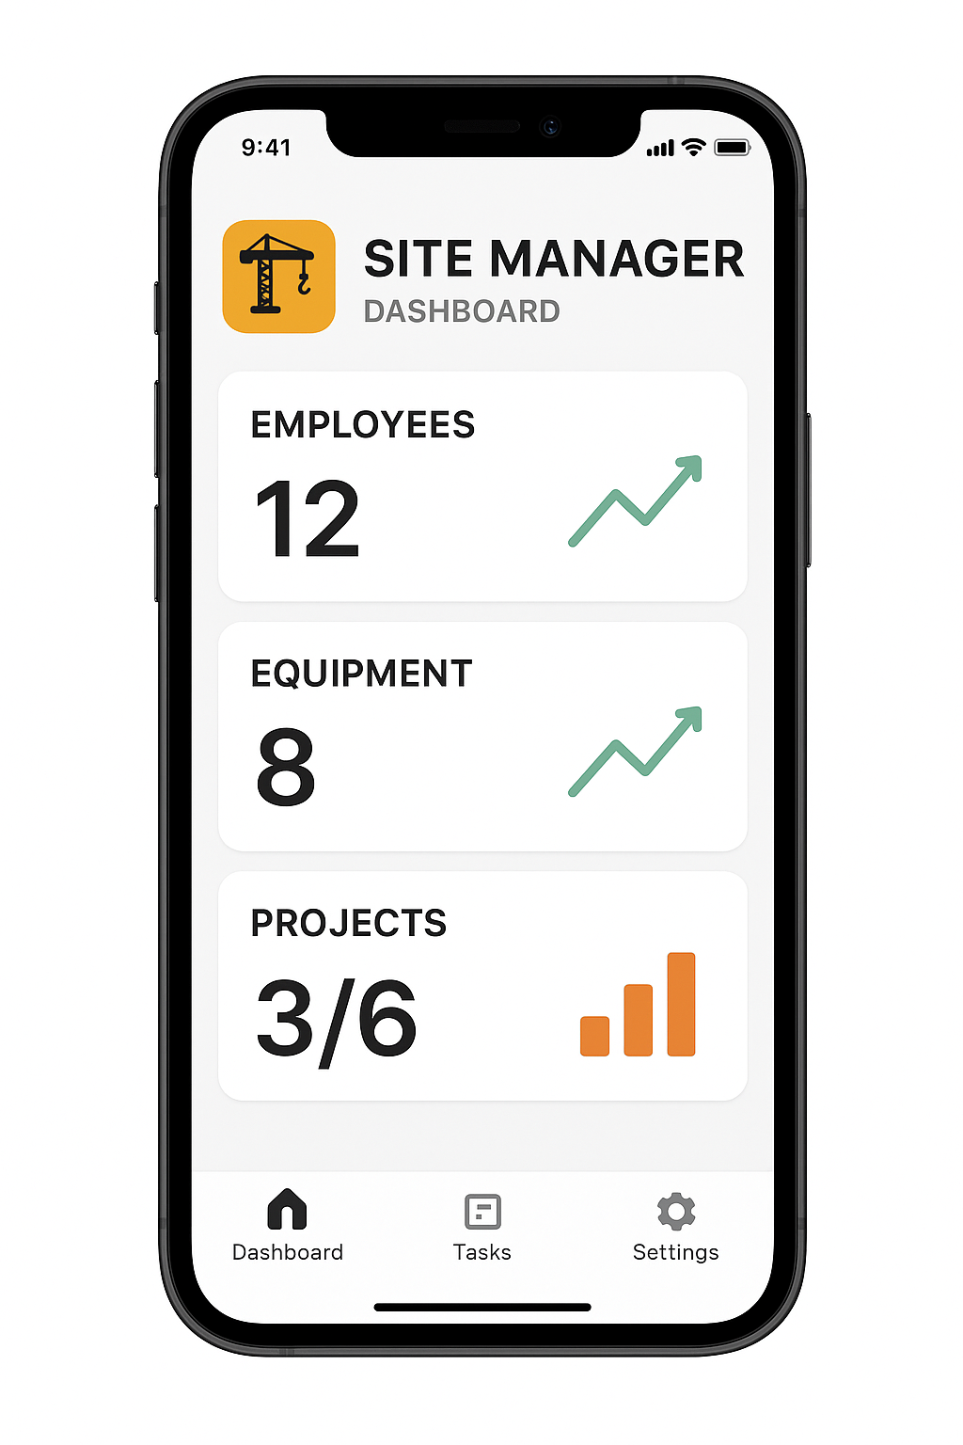

### Initial POVs

Before conducting needfinding interviews, our initial assumption was:

“Construction managers need a digital dashboard to track all projects, employees, and equipment in one place because current systems lack real-time visibility and lead to inefficiencies.”

This POV was broad and lacked specific insights into user pain points, such as maintenance tracking or material management. We assumed that a centralized dashboard would address most challenges but had not yet validated this with users.

Additional Needfinding Results

To dive deeper into the users’ needs, we conducted needfinding sessions, follow up interviews were hosted.To refine our understanding, we interviewed two key stakeholders in the construction industry:

Interviewees

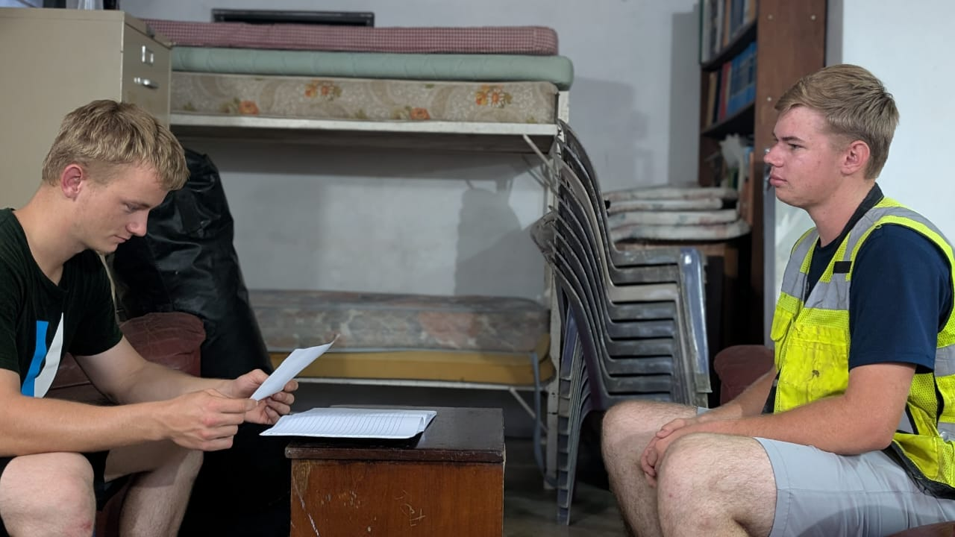

Gideon Banman (Equipment Operator, Banman Earthmoving)



Delroy Banman (Construction Foreman, Belize Roadway Construction)

Key Findings

Misrouting of Resources

Employees and equipment are frequently sent to the wrong project sites, causing delays.

Quote: “Misplacement happens all the time.” — Gideon Banman

Inefficient Manual Tracking

Paper-based systems for logging delays, materials, and maintenance are error-prone and time-consuming.

Example: Gideon described a scenario where a driver delivered a bucket to the wrong excavator due to unclear instructions.

Lack of Real-Time Insights

Current methods do not provide real-time updates on project progress or equipment condition.

Delroy noted that paper logs are often double-recorded, leading to inconsistencies.

Unexpected Needs

Users expressed interest in drone management systems and automated maintenance alerts, which were not part of our initial POV

#### **Revised Point of Views**

Based on the interviews, we revised our POVs to focus on specific pain points that potential users might face.

POV #1

“Because workers and equipment are often sent to the wrong job sites, which causes delays and inefficiencies, a construction foreman needs a visual map of where the project is and how resources are being used.”

POV #2

“An equipment operator needs a system to keep track of maintenance records and material lists for each project because keeping track of things manually is prone to mistakes and can cause misunderstanding about the state of the equipment and the needs of the project.”

POV #3

“A construction manager needs a simpler way to keep track of daily work results and delays because the current paper-based method systems are slow and do not show real-time progress on the project.”

##### HMW Statements

We generated HMW questions for each POV. Here are samples:

For POV #1 (Visual Map Interface)

* How might we create a visual map that helps foremen quickly identify misallocated resources?
* How might we integrate real-time updates into the map to reduce delays?
* How might we use color-coding to highlight critical issues (e.g., equipment failures)?

For POV #2 (Maintenance Tracking)

* How might we design a maintenance log that minimizes manual data entry?
* What might be the best way to streamline equipment condition reporting?
* How might we alert managers when maintenance is overdue?

For POV #3 (Daily Work Logging)

* How might we simplify the process of logging delays to save time?
* How might we incorporate photos into delay reports for better clarity?
* How might we make delay reporting mobile-friendly for on-site use?

###### Three Best HMW Statements

We selected the following HMWs to prototype:

1. **HMW #1:** “How might we create a visual map interface that helps foremen and managers allocate employees and equipment to the correct project sites?”
2. **HMW #2:** “How might we design a maintenance tracking system that reduces manual data entry and ensures equipment is always in optimal condition?”
3. **HMW #3:** “How might we streamline the process of logging daily work results and delays to provide real-time project insights for managers?”

###### 

###### 

###### Experience Prototypes

**Prototype 1: Visual Map Interface**

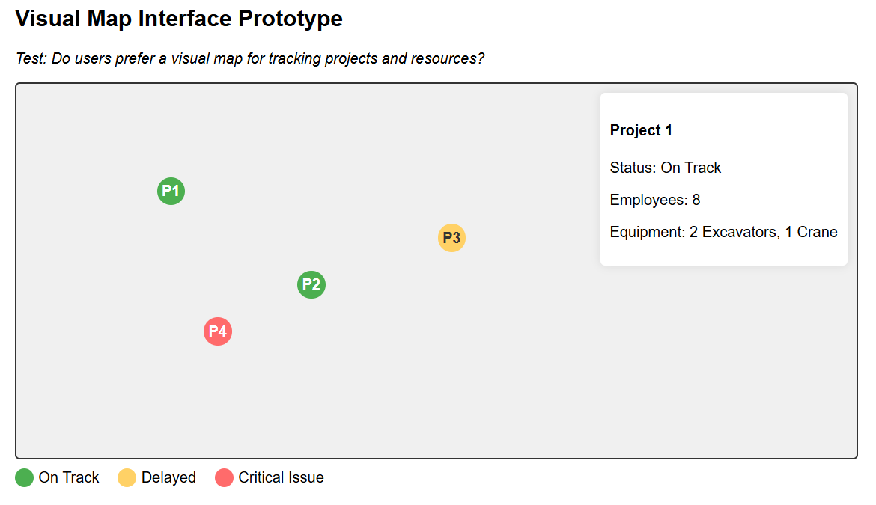

**Assumption Tested:** Users prefer a visual map for tracking projects and resources.

How We Made It:

We created a map with color-coded pins representing project statuses (green = on track, yellow = delayed, red = critical issue). Each pin included basic project details (e.g., employees, equipment).

**How We Tested It:**

Presented the map to users and asked them to allocate resources to a hypothetical project.

Observed whether they found the visual layout intuitive.

**Results:**

**What Worked:** Users appreciated the clarity of the visual overview and color-coding.

**What Didn’t Work:** The static map lacked real-time updates, which users wanted.

**What We Learned:** Users suggested linking equipment condition to the map (e.g., “Show which excavators need maintenance”).

**Validity of Assumption:** Valid, but users emphasized the need for digital integration.

**Prototype 2: Maintenance Tracking System**

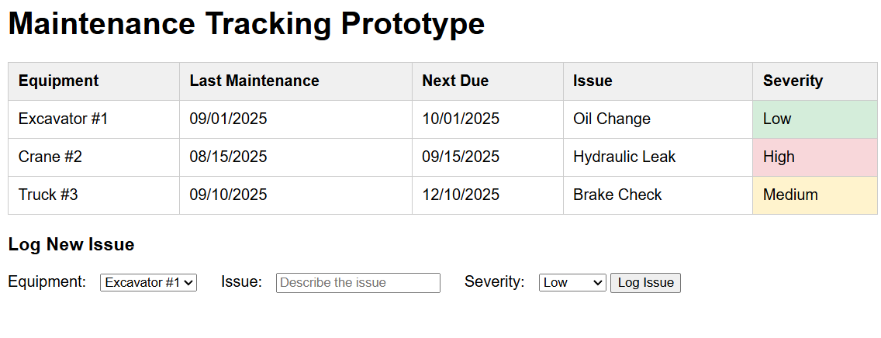

**Assumption Tested:** A simplified log can reduce errors in maintenance tracking.

**How We Made It:**

We designed a maintenance log with checkboxes for routine tasks (e.g., oil changes) and a severity scale for issues (low/medium/high).

**How We Tested It:**

Asked operators to log maintenance tasks using the prototype.

Observed whether they found it easier than their current paper-based method.

**Results:**

**What Worked:** Operators liked the structured format and severity scale.

**What Didn’t Work:** Manual entry was still seen as tedious; users wanted automated reminders.

**What We Learned:** Operators suggested using mobile scanning (via QR codes) to log issues faster.

**Validity of Assumption:** Partially valid: Simplified logs help, but automation is key.

**Prototype 3: Daily Work Logging**

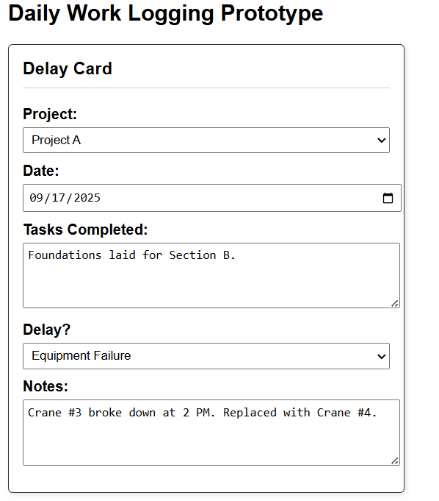

**Assumption Tested:** A structured log improves delay reporting.

**How We Made It:**

We created physical “delay cards” with dropdown options for delay reasons (e.g., weather, equipment failure) and space for notes/photos.

**How We Tested It:**

Asked managers to log delays using the cards.

Observed whether the standardized options reduced ambiguity.

**Results:**

**What Worked:** Standardized delay reasons reduced reporting errors.

**What Didn’t Work:** Cards were easily lost; users preferred a digital form.

**What We Learned:** Managers wanted to attach photos of delays (e.g., broken equipment).

**Validity of Assumption:** Valid, but a digital solution is preferred.

###### Most Successful Prototype

The Visual Map Interface was the most successful because:

It directly addressed the misrouting issue, a major pain point for users.

Users immediately understood the color-coded system.

It laid the foundation for future digital features (e.g., real-time updates, equipment condition alerts).

We recommend moving forward with this prototype and adding interactive elements (e.g., clickable pins for project details).

###### Conclusion

**Key Insights:**

**Visual tools can be very useful:** Maps and color-coding improve resource allocation.

**Automation is important:** Users reject manual data entry; solutions must minimize effort.

**Unexpected needs matter:** Features like maintenance tracking and photo uploads emerged as valuable.

Next Steps

* Develop a digital prototype combining the map, maintenance alerts, and mobile-friendly delay reporting.
* Test the digital prototype with real users to validate usability.
* Explore drone integration for site monitoring (based on Delroy’s interest).

**Why This Matters,**

It would help in Reducing project delays (by minimizing misrouting and downtime), cut manual tracking time (through automation) and Improve equipment longevity (via maintenance alerts).

**Declaration of Use for Generative AI in Assessments** 

I hereby declare that in the planning, drafting, and/or revision of the work attached, I have made use of Generative AI tools in the following ways:

# **Acknowledgement of Generative AI Tools Used**

☐ For brainstorming. ☐ To generate translations of primary/secondary source content for consultation.

☐ To find sources. ☐ To generate translations included in the submitted work, whether or not manually revised.

☐ To plan the structure/outline of the work. ☐ To improve the language of my own phrases, sentences, and/or paragraphs.

☐ To generate programming code. ☐ To generate the text of (part of) the submitted work.

# **Acknowledgement of Assessment Submission**

I, **Enrique Garcia, Kelvin Gordon, Joseph Koop,**  hereby confirm that on **21/09/2025**:

1. I am the author of this submitted document.
2. I am responsible for any AI-generated errors or fabrications.
3. I understand the limitations and risks of using AI.
4. I used AI tools ethically, protecting all sensitive information.
5. I ensure any AI-assisted work remains originally my own.
6. I have appropriately acknowledged all use of generative AI.
7. Undeclared AI use constitutes academic dishonesty, which I acknowledge.
8. I am accountable for any resulting academic misconduct.

*Add more rows to the table as needed to include ALL tools used in the creation of your assessment submission.*

| **Generative AI Tool Used**  ***(Please List Each Separately)*** | **Purpose of Use** | **Briefly Explain the Extent of Use** |
| --- | --- | --- |
| Grammarly | Grammar check | was used to double check grammar in the essay |
| chatgpt | punctuation , vocabulary, grammatical check | was used to rephrase or complete sentences that were missing something so it would sound better. |
| chatgpt | Generate image | Was used to generate image in page 2 of a mobile ui for the app and Cover Image of app |

| **Student Name: Enrique Garcia, Kelvin Gordon** |  | **Student Id:** 2022156818, 2018117973, |
| --- | --- | --- |
| **Course Code: CMPS3141** |  | **Department:Department of Mathematics, Physics and Information Technology** |
| **Signature:** |  | **Date:** 21/09/2025 |